Fall Armyworm (FAW) Leaf Classification using Deep Learning

Project Overview

Fall Armyworm (Spodoptera frugiperda) is a destructive pest that affects maize crops across Africa and other regions. Early detection of infestation is critical to prevent yield loss.
This project implements a Convolutional Neural Network (CNN) based image classification model to automatically identify maize leaf conditions as:
- Healthy
- Damaged
- Larva-infected
The system leverages transfer learning using MobileNetV2 and is deployed as an interactive web application using Gradio.

System Architecture

Workflow Overview

1. Data Collection
Images of maize leaves were organized into three classes: `healthy`, `damage`, and `larva`.
The dataset was divided into:

- Training set
- Validation set (via data split)
- Test set

2. Preprocessing & Augmentation
The dataset was augmented using the `ImageDataGenerator` class in Keras to enhance model robustness against overfitting.
Transformations included:

- Rotation: ±25°
- Zoom: ±20%
- Shear and horizontal flip
- Rescaling: pixel values normalized to [0,1]

3. Model Training
The MobileNetV2 pretrained on ImageNet served as the **feature extractor**, with its top layers removed and a custom classification head added.
The new head consisted of:

* `GlobalAveragePooling2D`
* `Dropout(0.3)`
* `Dense(num_classes, activation='softmax')`

4. Optimization

- Optimizer: Adam
- Learning Rate: 0.001
- Loss Function: Categorical Crossentropy
- Metric: Accuracy
- Early stopping and model checkpoint callbacks were used to avoid overfitting.

5. Evaluation
The trained model was evaluated on unseen test data using:
- Accuracy
- Classification Report (Precision, Recall, F1-score)
- Confusion Matrix

6. Deployment

- Model converted to ONNX format using `tf2onnx`
- Inference tested via ONNX Runtime
- Interactive web interface built using Gradio

Dataset Summary

| Dataset Split | Number of Images | Classes |
| -------------- | ---------------- | -------------------------- |
| Training Set | 2,114 | 3 |
| Validation Set | 527 | 3 |
| Test Set | 802 | 3 |
| Total | 3,443 | Healthy, Damage, Larva |

All images were resized to 224×224 pixels before training.

Model Architecture

Base Network: MobileNetV2 (pretrained on ImageNet, include_top=False)
Custom Head:
```python
x = GlobalAveragePooling2D()(base_model.output)
x = Dropout(0.3)(x)
output = Dense(num_classes, activation='softmax')(x)
model = Model(inputs=base_model.input, outputs=output)
```

Frozen Layers: All layers of MobileNetV2 were initially frozen to preserve pretrained weights.
Trainable Parameters: Only the top classification layers were trained.

Model Training Configuration

| Parameter | Value |
| ------------- | --------------------------- |
| Optimizer | Adam |
| Learning Rate | 0.001 |
| Loss Function | Categorical Crossentropy |
| Batch Size | 32 |
| Epochs | 10 (early stopping applied) |
| Input Shape | (224, 224, 3) |

Callbacks:
```python
EarlyStopping(monitor='val_accuracy', patience=3, restore_best_weights=True)
ModelCheckpoint('best_faw_model.keras', monitor='val_accuracy', save_best_only=True)
```

Performance Metrics

After training, the model achieved high accuracy on both training and test sets.

Example Results:

```
Test Accuracy: ~95%
```

Classification Report:

| Class | Precision | Recall | F1-Score |
| ------- | --------- | ------ | -------- |
| Healthy | 0.96 | 0.94 | 0.95 |
| Damage | 0.93 | 0.96 | 0.94 |
| Larva | 0.95 | 0.95 | 0.95 |

Confusion Matrix Visualization:
A heatmap was plotted using Seaborn to visualize classification performance.
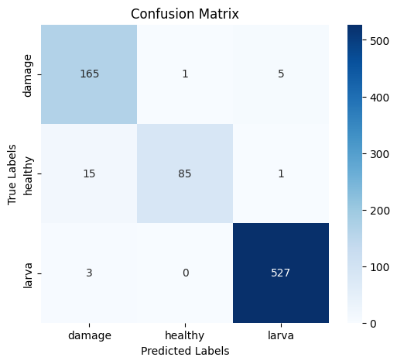

Model Conversion & Inference (ONNX)

The trained TensorFlow model was exported to **ONNX format** for interoperability and deployment in other frameworks:

```python
import tf2onnx
spec = (tf.TensorSpec((None, 224, 224, 3), tf.float32, name="input"),)
model_proto, _ = tf2onnx.convert.from_keras(model, input_signature=spec, output_path="faw_model.onnx")
```

Inference with ONNX Runtime:

```python
import onnxruntime as ort
session = ort.InferenceSession("faw_model.onnx")
preds = session.run([output_name], {input_name: img_input})[0]
```

Web Application (Gradio Interface)

To make predictions accessible to end users, a Gradio app was developed:
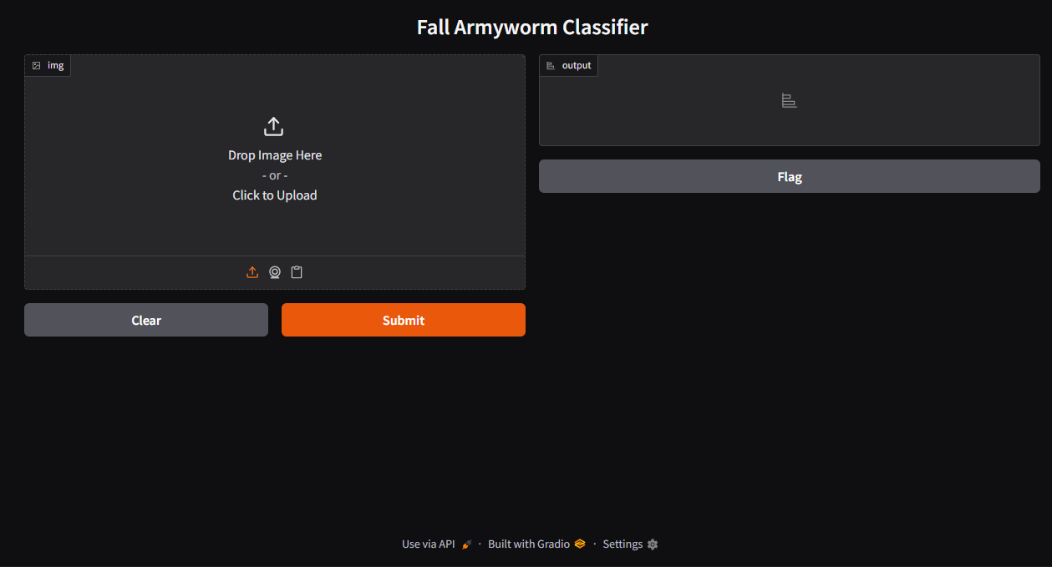
```python
import gradio as gr
import onnxruntime as ort
import numpy as np
import cv2

def predict_image(img):
img = cv2.resize(img, (224, 224))
img_norm = img.astype(np.float32) / 255.0
img_input = np.expand_dims(img_norm, axis=0)
preds = session.run([output_name], {input_name: img_input})[0]
pred_class = np.argmax(preds)
conf = np.max(preds)
return {class_names[pred_class]: float(conf)}

gr.Interface(fn=predict_image,
inputs=gr.Image(type="numpy"),
outputs=gr.Label(num_top_classes=3),
title="Fall Armyworm Classifier").launch()
```

Functionality:

- User uploads a maize leaf image.
- Model outputs predicted class (`Healthy`, `Damage`, `Larva`) with confidence percentage.

Dependencies

Install all required libraries:

```bash
pip install tensorflow keras tf2onnx onnx onnxruntime matplotlib scikit-learn opencv-python albumentations gradio
```

Future Improvements

- Fine-tune the pretrained layers of MobileNetV2 for even higher accuracy.
- Expand the dataset with field images under different lighting and background conditions.
- Deploy the model as a **mobile app** for real-time leaf scanning.
- Integrate **edge inference** using TensorFlow Lite or ONNX Runtime Mobile.

Author

Appah Oyinmiebi Joseph
Machine Learning Engineer | Agricultural AI Researcher
[LinkedIn Profile](https://www.linkedin.com/in/oyinmiebi-appah-87911535b/)

